Anchor

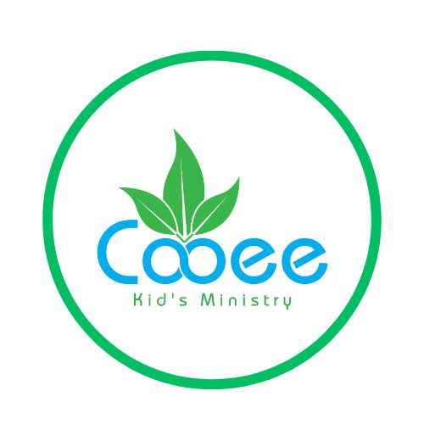

By Deborah Wassenberg

Introduction:

In the ancient world an anchor was used as a picture of hope. The writer of Hebrews knew this when he wrote, ‘we have this hope as an anchor for the soul, firm and secure’. We can hold onto confident expectations because God **never** lies.

Bible Lesson: God’s Promise to Abraham

Bible References: Genesis 17:1-22; 18: 1-15; 21:1-8; Hebrews 6:9-20

Visuals You Will Need:

Picture 1: An anchor (fluked or admiralty type)

Picture 2: Ship with anchor lowered to seabed

Picture 3: Anchor chain, cable or rope

Picture 4: Bible

Picture 5: Abram and Sarai

Picture 6: Abraham and the stars in the sky

Picture 7: Abraham and Sarai in old age

Picture 8: 3 Visitors

Picture 9: Preparations for the meal

Picture 10. Sarah laughing

Picture 11. The Lord talking to Abraham and Sarah

Picture 12. Abraham, Sarah and baby Isaac

Words:

1. Do you know what this is? Yes, it’s an anchor. And every ship needs one. It’s a metal object with curved arms called flukes. An anchor is not only heavy but it hooks into the seabed, too. An anchor is attached to a strong rope, cable or chain, which is dropped from the ship, into the water. A ship will ‘drop anchor’ when it wants to stop. And it will ‘weigh anchor’ when it is time to pull up the anchor and sail away.
2. Do you know what an anchor does?

* An anchor is needed to hold a ship in place and stops it from being wrecked.
* An anchor stabilizes the ship, keeps it steady, so the sailors and passengers are more comfortable.
* An anchor stops the ship from going backwards.

1. Just like a ship uses thick ropes or steel cables or heavy chain to hold onto ananchor, we have to hold onto God. The anchor is doing its job when you don’t even see it! It’s gone overboard with a splash, down and down, to the ocean floor. It’s the same with hoping in God. You may not see anything but He is holding tight onto you.
2. God has made lots of promises in the Bible. He has promised to help us (Hebrews 13:6). He has promised to provide everything we need (Philippians 4:19). God has promised to heal (Isaiah 53:5). He has promised to answer our prayers (Matthew 11:24). He has promised to give us strength (Philippians 4:13). God has promised us joy, deliverance and eternal life. I could go on and on because there are thousands of promises in the Bible!
3. But what if you have to wait? If what God has promised doesn’t happen right away? Abram (God later changed his name to Abraham) was a man who waited and waited.

God spoke to Abram in a vision.

‘Do not be afraid Abram.

I am our shield and your very great reward.”

1. Abram protested, “Sovereign Lord, You have not given me any children and the person who will inherit all I have is my servant, Eliezer of Damascus.”

“Eliezer will not inherit but a son of yours will,” God replied.

God took Abram out to look at the night sky.

“Look up at the sky and count the stars – if indeed you can count them.

Your offspring will be as numerous as the stars.”

1. Abram and his wife Sarai became older and older without having a family of their own.

Abram was given the name Abraham by God.

It means ‘father of many nations’!

God also gave Sarai the name, Sarah, promising she would have a son even though she was 90 years old.

1. While Abraham was sitting near the entrance to his tent, he looked up and saw three men standing nearby. The bible says one of these was the Lord.

Abraham bowed down and said, ‘Let me bring you water to wash your feet and then rest here while I bring you food. When you are refreshed you can then go on your way.’

1. Abraham rushed to ask Sarah to bake fresh bread. He chose a choice calf and gave it to a servant to slaughter and cook the meat. Then he poured his fresh milk and curds and served it to his guests. As they ate Abraham waited on them in the shade of the trees.
2. ‘Where is Sarah, your wife?’ the visitors asked.

She’s inside the tent,’ Abraham replied.

Then one of them said, ‘I will return to you about this time next year, and our wife, Sarah, will have a son!’

Sarah was listening to this conversation from the tent.

Abraham and Sarah were both very old by this time, and Sarah was long past the age of having children. So she laughed silently to herself.

1. Then the Lord said to Abraham, ‘Why did Sarah laugh? Why did she say, ‘Can an old woman like me have a baby?’

Is anything too hard for the Lord? I will return about this time next year, and Sarah will have a son.’

Sarah was afraid, so she denied it, saying, ‘I didn’t laugh.’

But the Lord said, ‘No, you did laugh.’

1. The Lord kept his word and did for Sarah exactly what he had promised.

She became pregnant, and she gave birth to a son.

Abraham named their son Isaac.

God does exactly what He said He would do.

Because of his faith in God, Abraham is one of the heroes of the Bible.

God’s promise to Abraham even included us! (Galatians 3:29 & John 1:12)

Ministry to the Children:

Don’t become discouraged if you have to wait for something God has promised you. God’s promises are reliable. It’s easy to think, ‘Will God ever answer my prayers?’ The devil likes to use times like this to attack you. He’ll lie to you and say: ‘It will never happen. God has forgotten you. Can God even be trusted?’ But remember, it’s impossible for God to lie! And the rougher the weather the more important it is to have an anchor! You are sturdy, secure and shipshape.

Memory Verse: Psalm 25:5

Guide me in your truth and teach me, for you are God my Saviour, and my hope is in you all day long.

Write the words of the Memory Verse onto A4 cards. You’ll need two blindfolds. Divide the children into two teams. Each team must choose someone to be blindfolded and someone to call out instructions. Set up an easy obstacle course. Along the course will be stations to pick up words of the Memory Verse e.g. on a chair, inside a box, under a table. The caller must call directions out to the blindfolded team member. The blindfolded child must listen carefully and trust the caller’s instructions to find the word. Change caller and blindfolded child after each word is found.

Game:

**Tug-O-War:** The rope used should be of a circumference of approximately 11 cm and should be marked in the middle with a centre line as well as two marks that should be placed 4m from the centre line. At the start of the pull, the centre line of the rope should be immediately above a line marked on the ground. Both teams pull the rope, the winner being the team who manage to pull the mark on the rope closest to their opponents over the centre line. The rope must be pulled underarm and nobody’s elbow must go below the knee. Matches are often a best of three pull, the winner winning two out of the three pulls. It’s fun to have a matches kids vs leaders or boy’s vs girls.

Craft: Paper Plate Sailboat

You will need:

* Paper plate per child
* Felt pens
* Paper for sails and anchor
* Trimmed bamboo skewers (remove the sharp point) for the mast
* Thin rope to attach anchor to the boat
* Sticky tape and glue
* Optional: the Memory Verse printed out

What to do:

* Fold paper plate in half so it can gently rock like a boat
* Draw on the details of the hull
* Attach mast
* Colour and decorate the sail and anchor
* Add sail to the mast
* Attach anchor to the boat
* Glue the Memory Verse to the side of the hull

